Objectives:

* Conditional IF statements, nested if statements
* Try statement, file, print and buffered writers

**There are 5 challenge exercises, each worth 20%**

**Project #1 (Using the IF statement)**

**Challenge Exercise #1**: (Convert the project #1 into a J-Option Pane).

**#1 print screen the output with code below here.**

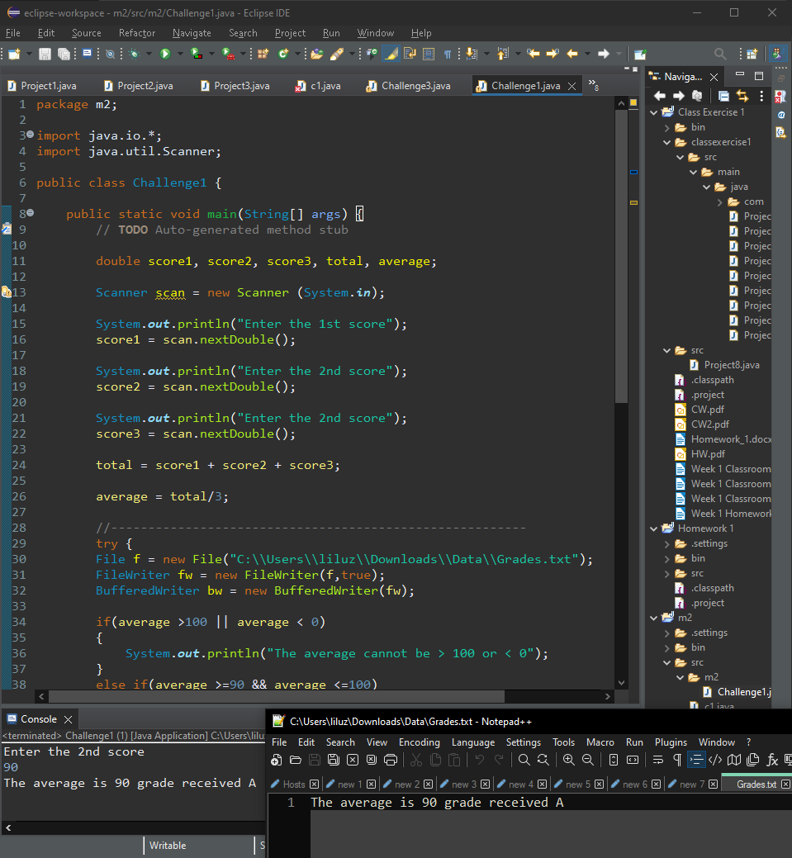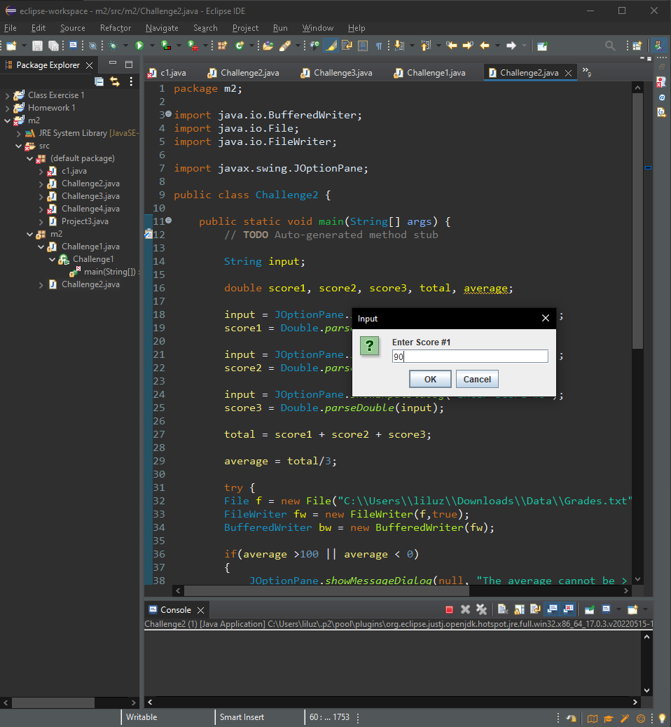

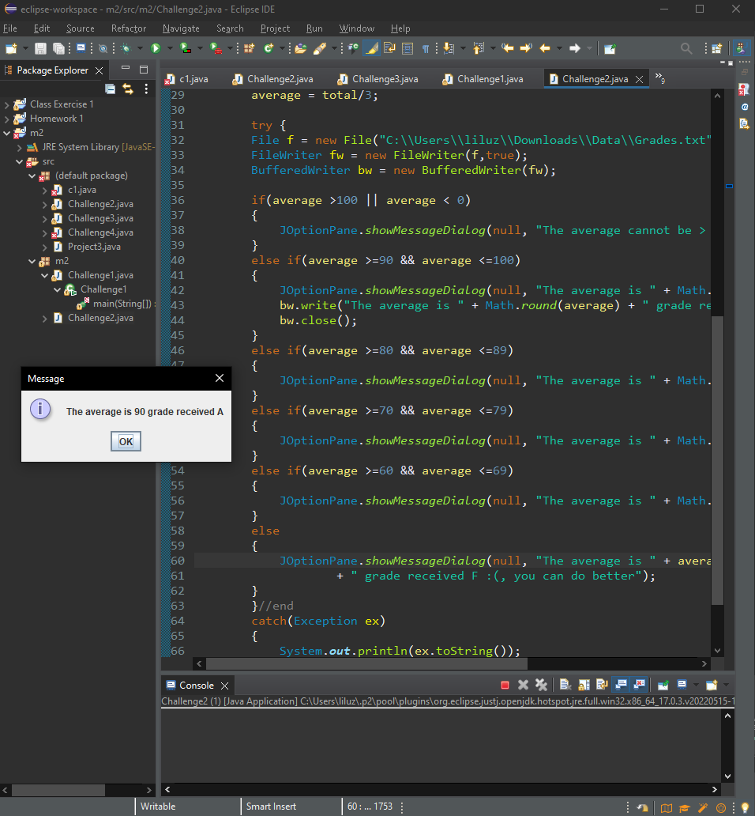

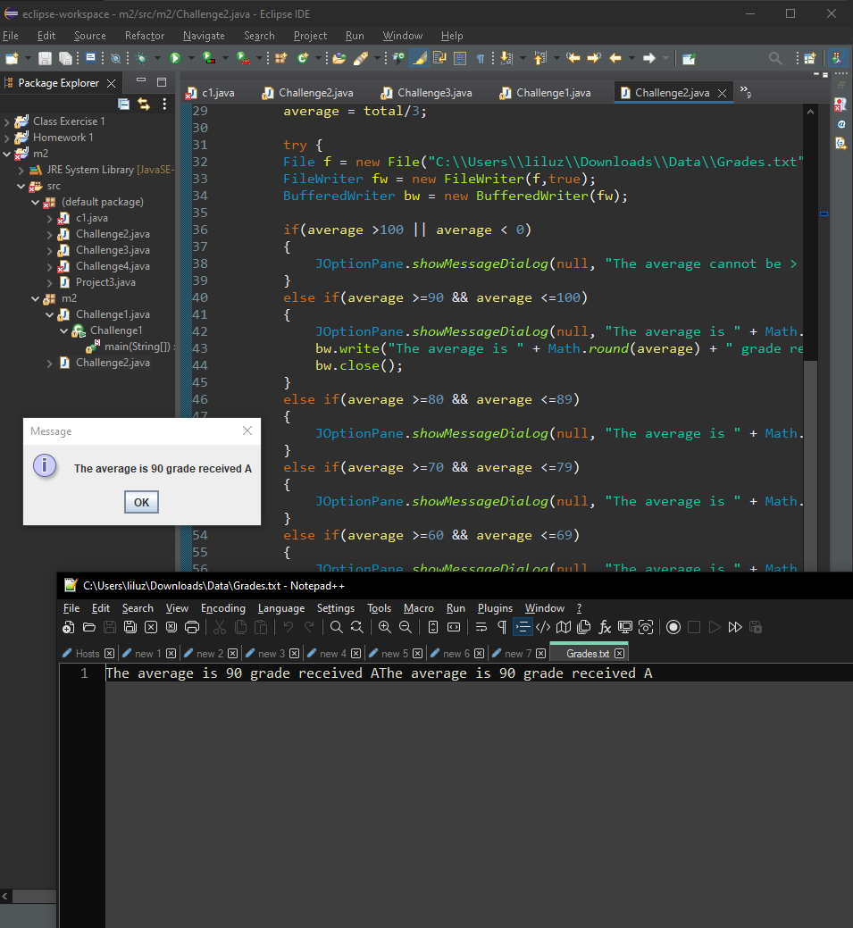

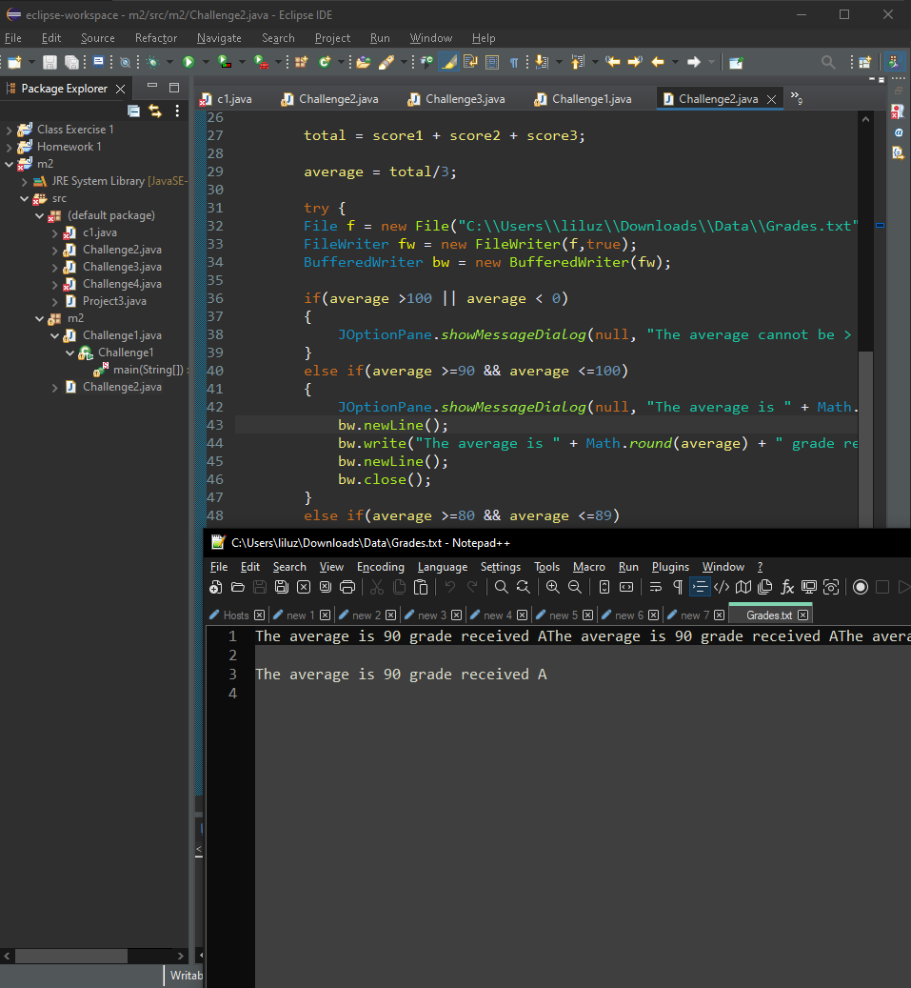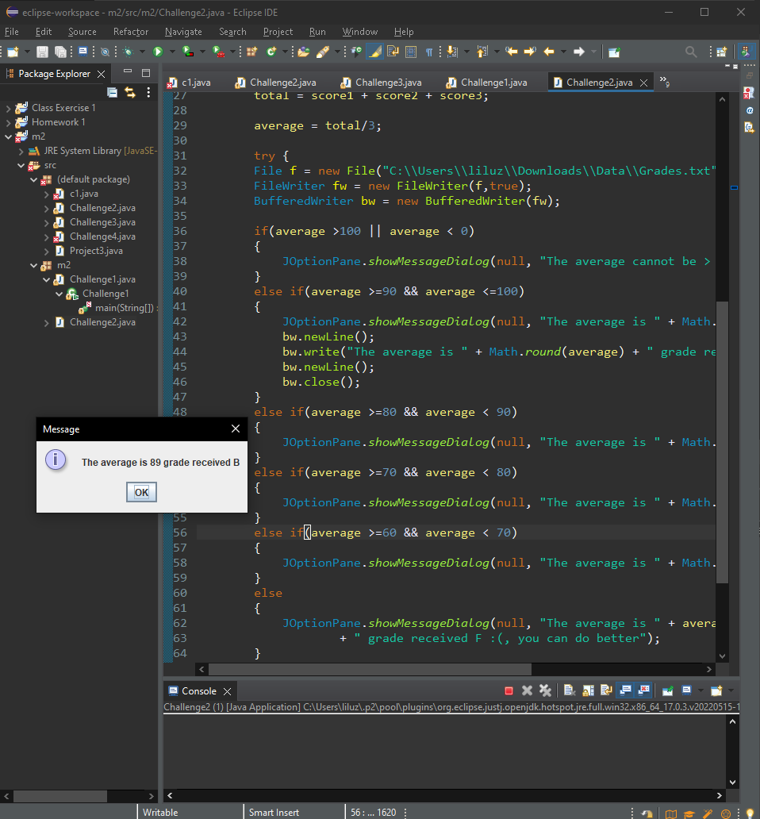

**Project #2 (Using the If statement and Division)**

**Challenge exercise #2:** Turn to page 179 and complete the Algorithm Workbench #3

**#2 print screen the output with code below here.**

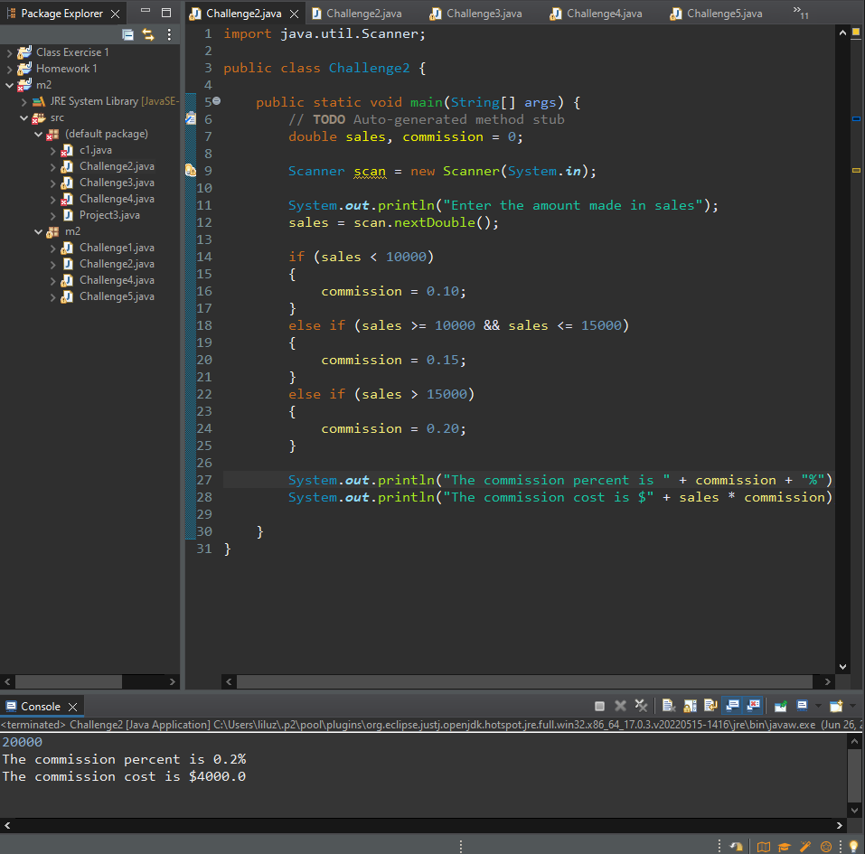

**Project #3 (Using a nested if Statement to test more than ONE condition)**

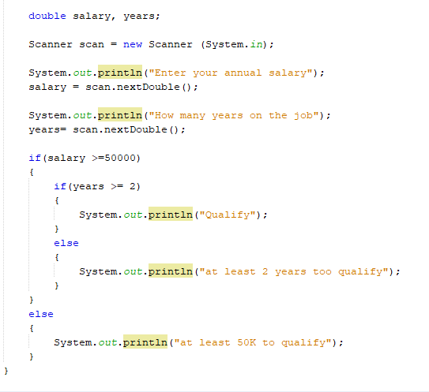

Or you can write it using the && operator, two or more conditions must be true

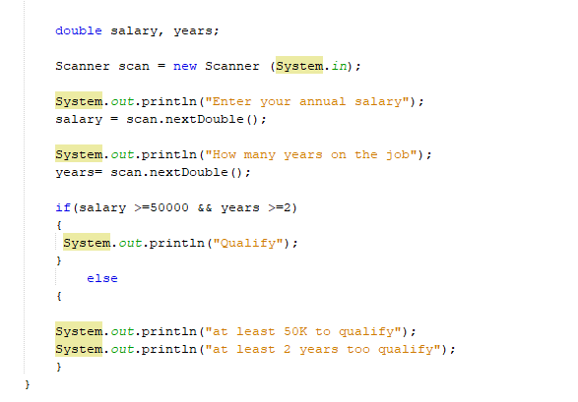

**Challenge Exercise #3:** Turn to page 183 and complete question #9 (Shipping Charges)

**#3 print screen the output with code below here.**

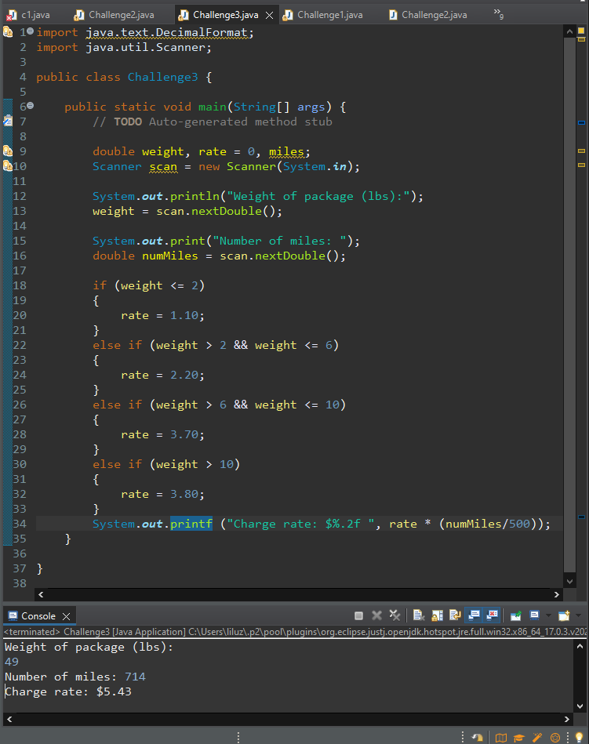

**Project #4 (Using multiple nested if statements)**

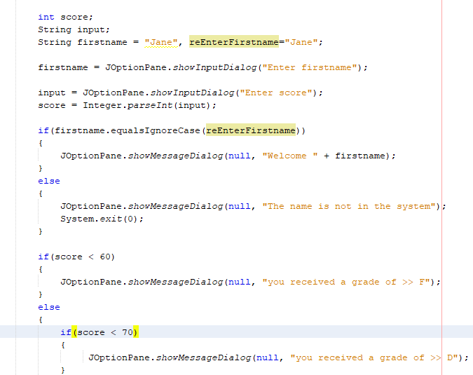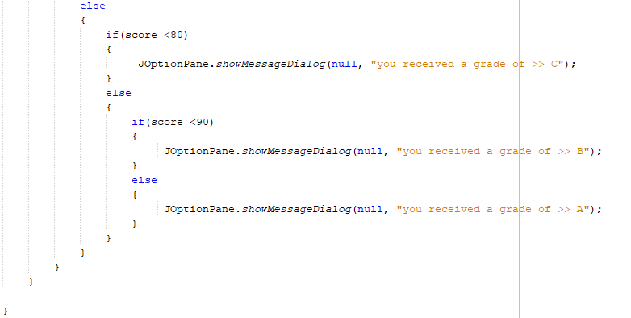

**Challenge Exercise #4:** Turn to page 185 and complete question #15 (Bank Charges)

**#4 print screen the output with code below here.**

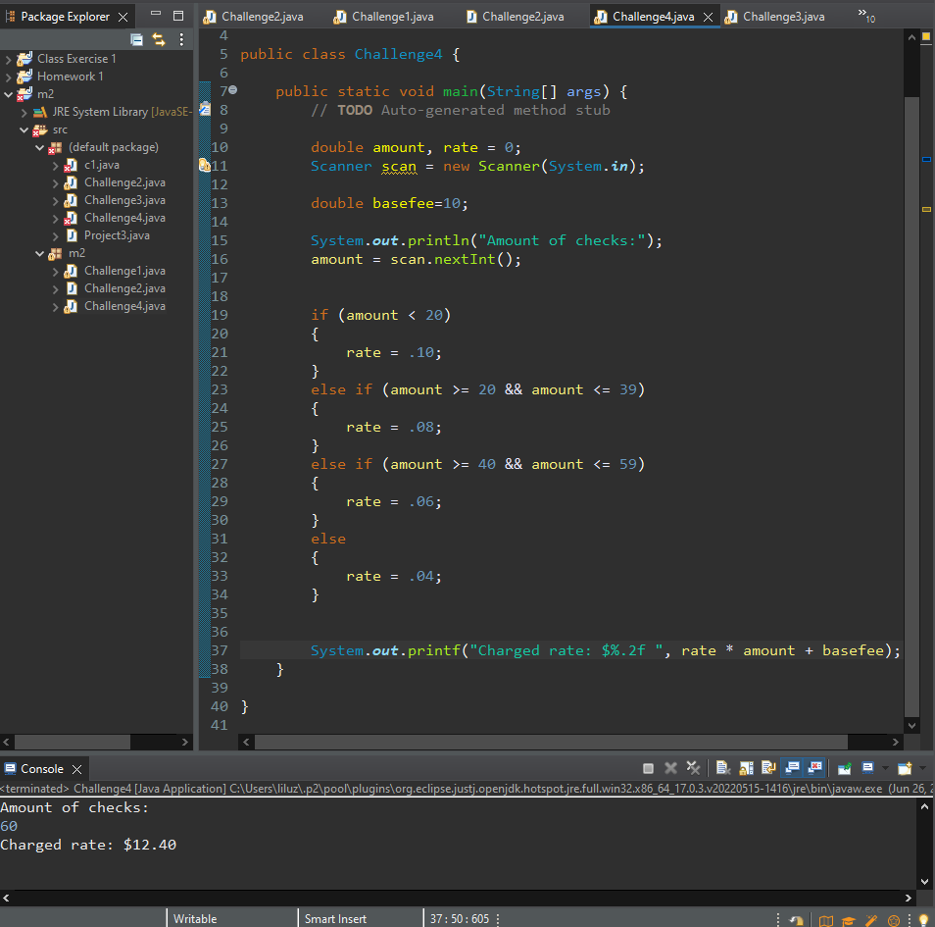

**Project #5 (Using the try and catch statement with conditional if statements)**

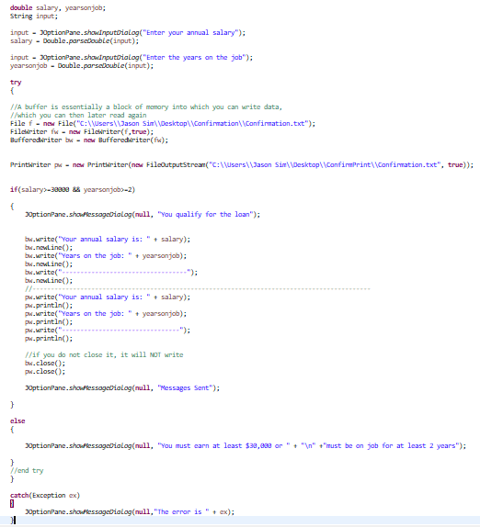

**Project #6 (Using Integers for cases)**

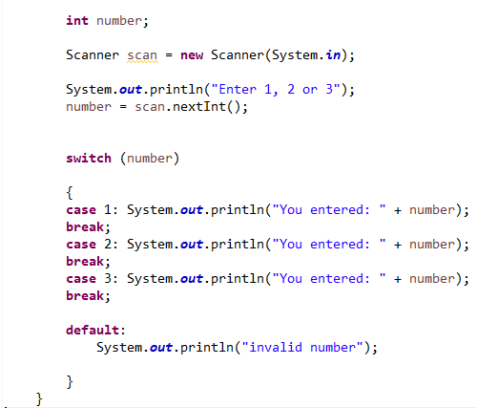

Using an IF statement with cases (See arrow below)

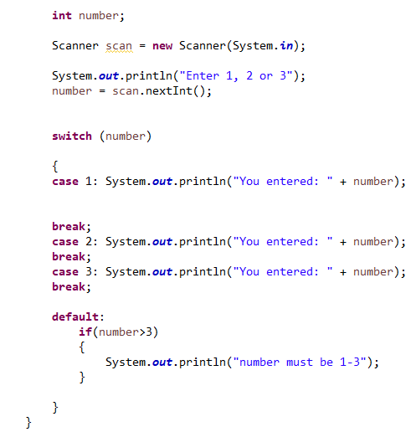

**Project #7 (Using Strings on cases)**

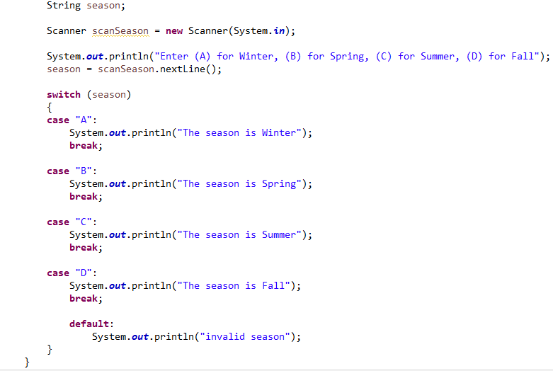

**Challenge Exercise #5:** Turn to page 185 and complete question #16 (Book Club Points)

**#5 print screen the output with code below here.**

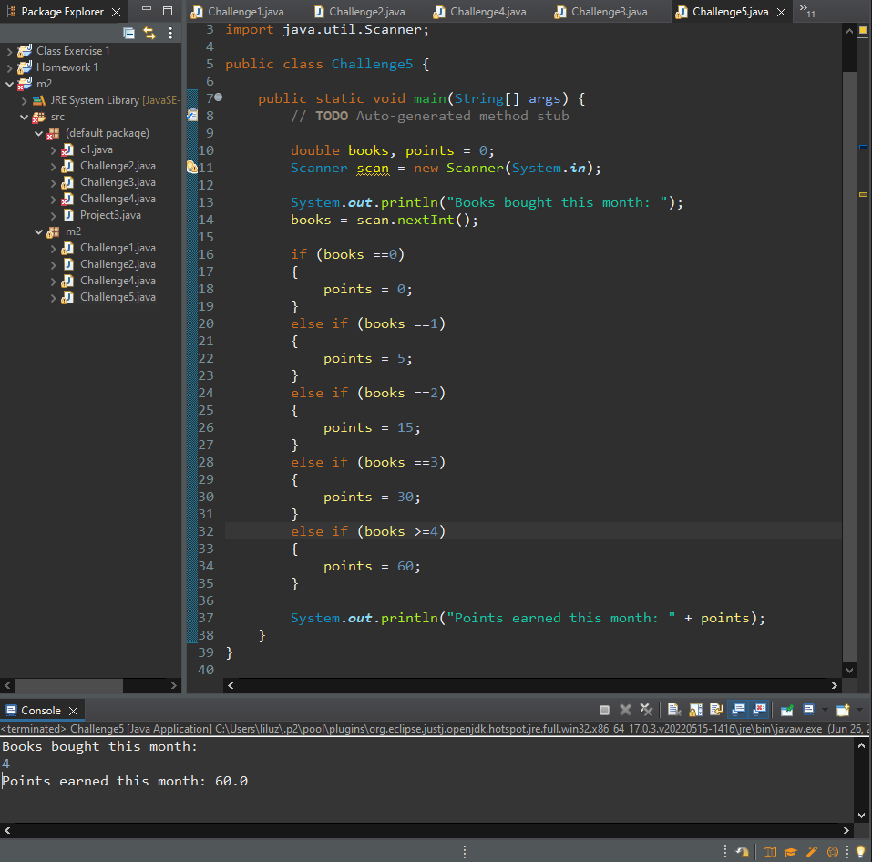

**Submit this document to module 2 Class exercise.**